**Deploy an Auto Scaling Group with Load Balancer**

**Objective:**

Implement high availability and scalability by deploying an Auto Scaling Group (ASG) behind an Application Load Balancer (ALB).

**Why?**

Distribute traffic evenly

Ensure fault tolerance

**Prerequisites:**

AWS Account

Terraform Installed

Ansible Installed

**Steps**

Define Launch Template

EC2 instance configuration (AMI, instance type, key pair)

Create Auto Scaling Group

Desired capacity, min/max size

Create ALB

Register ASG instances in target group

Use Ansible for App Deployment

Install and configure application on all EC2 instances

Simulate load using Apache Benchmark

**Validation**

Access ALB DNS name in browser

**Verify:**

Application is reachable

**Deliverables**

Terraform Files: ASG + ALB configuration

Ansible Playbook: Application deployment

Load Test Results

**Steps 1: Install the terraform and ansible**

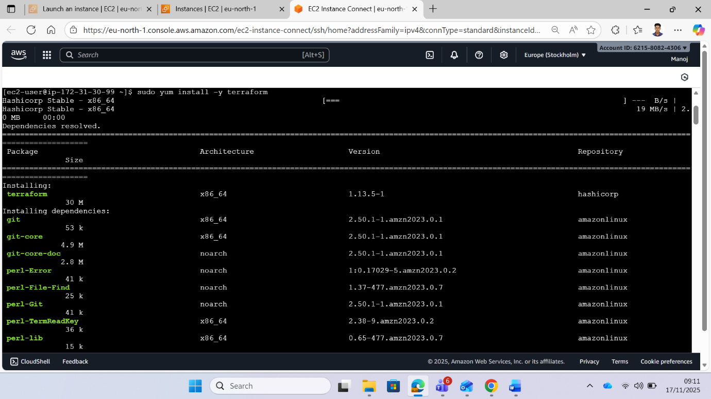

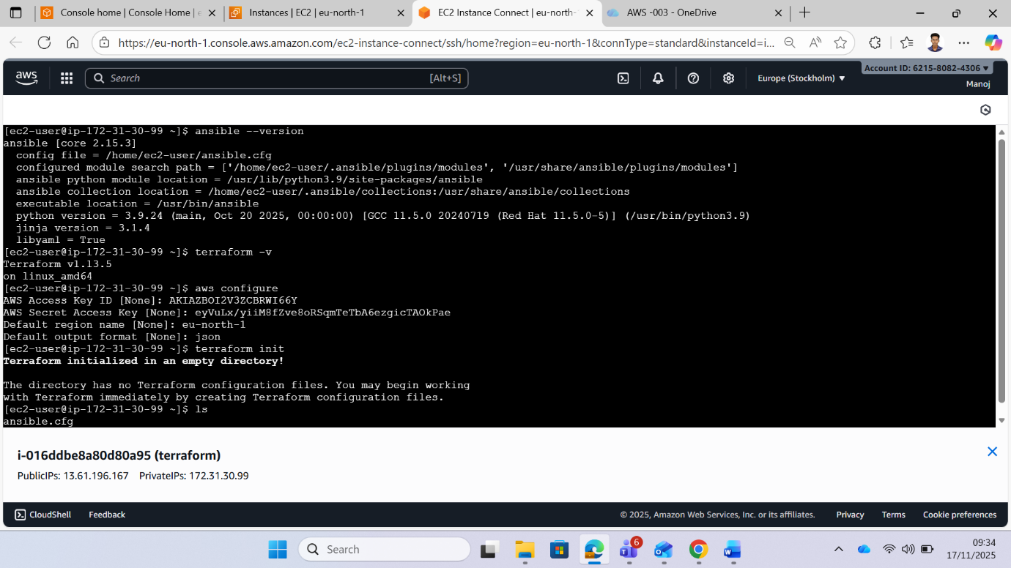

**Step 2 : create an IAM access key and secret key in AWS**

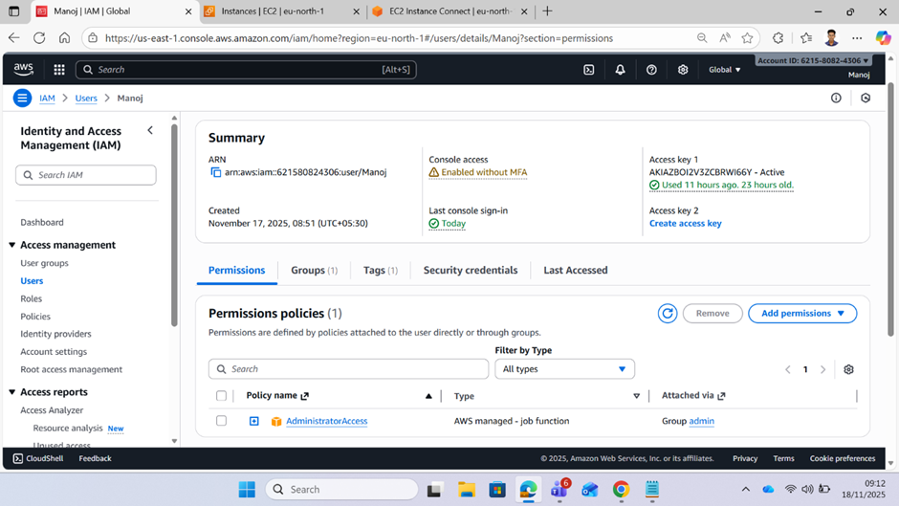

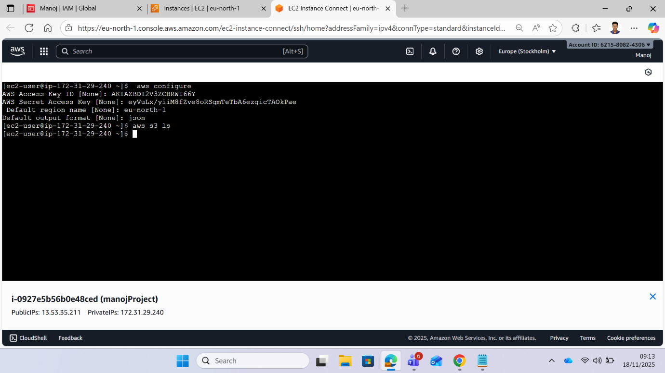

**Step 3: Initialize Terraform – Created configuration files (security.tf, network.tf, launch_template.tf) and initialized provider plugins using terraform init.**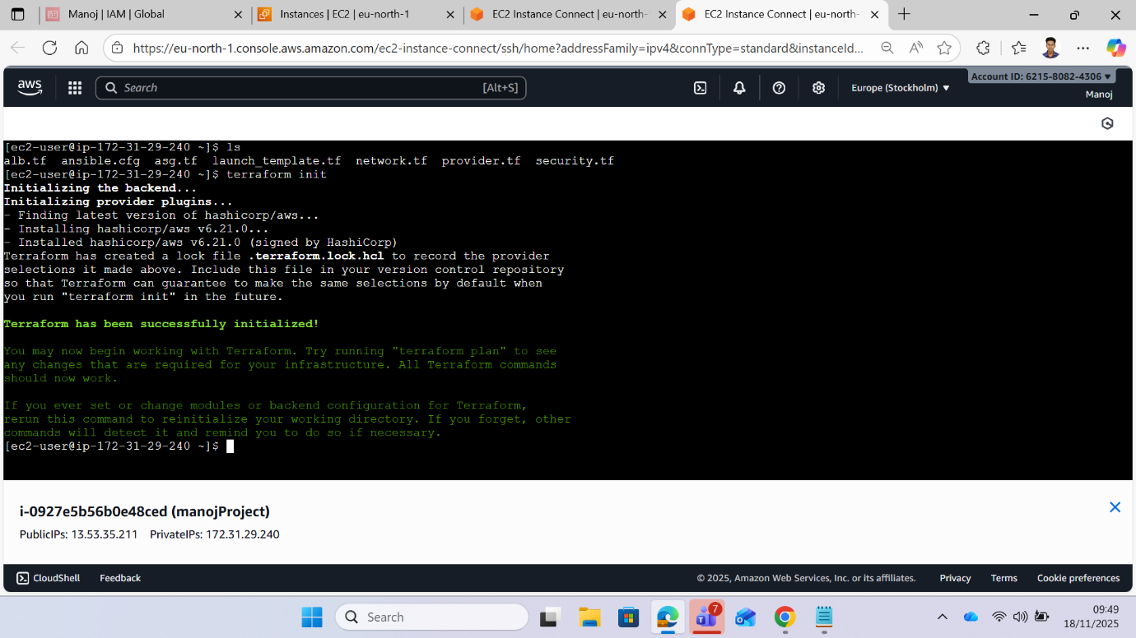

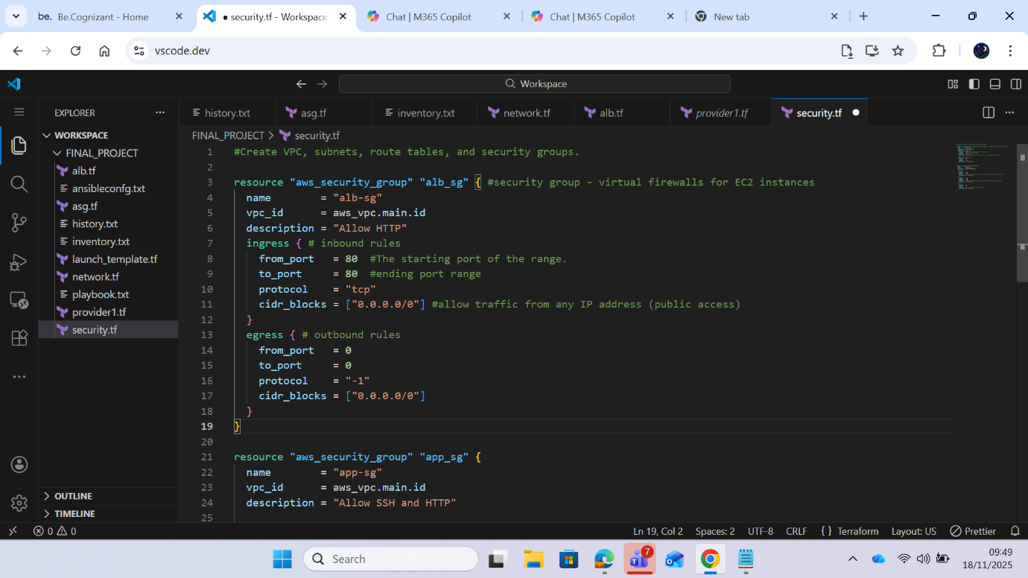

**Step 4: Run terraform plan**

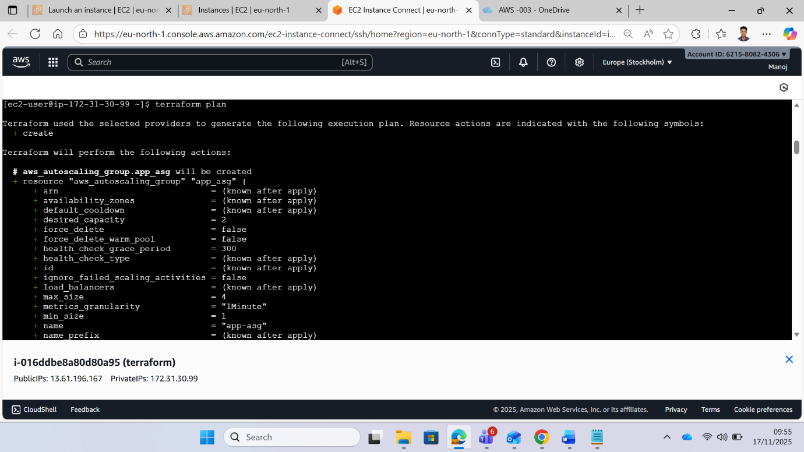

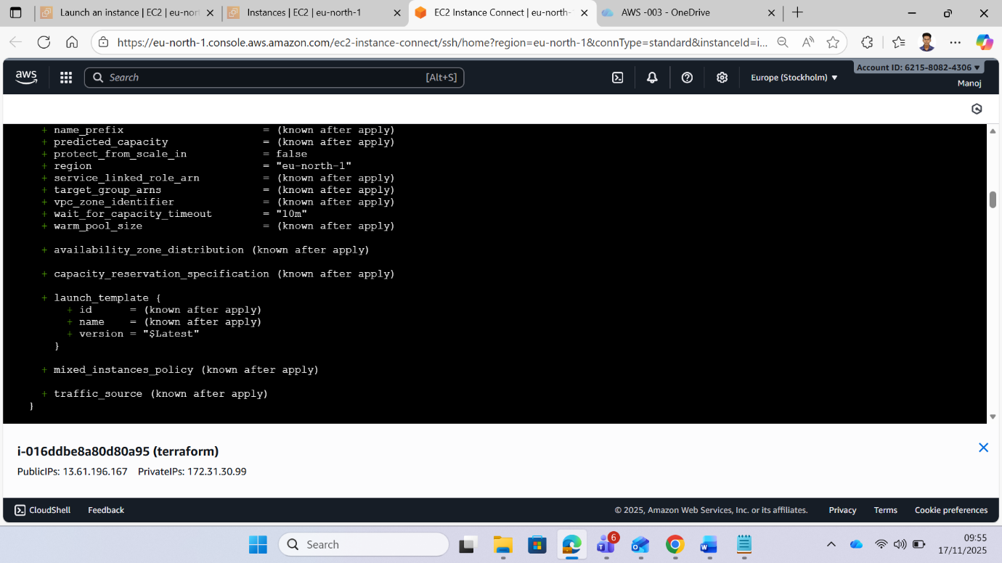



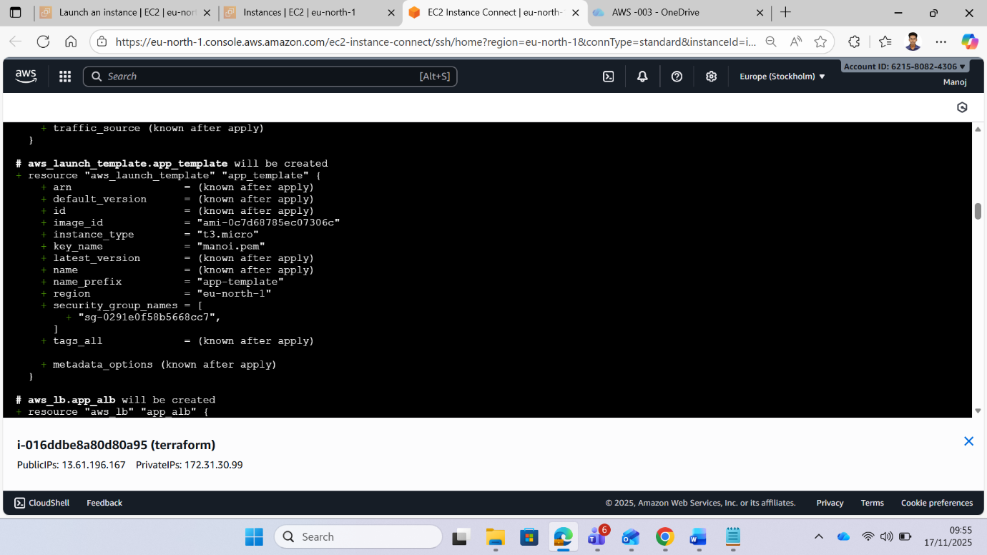

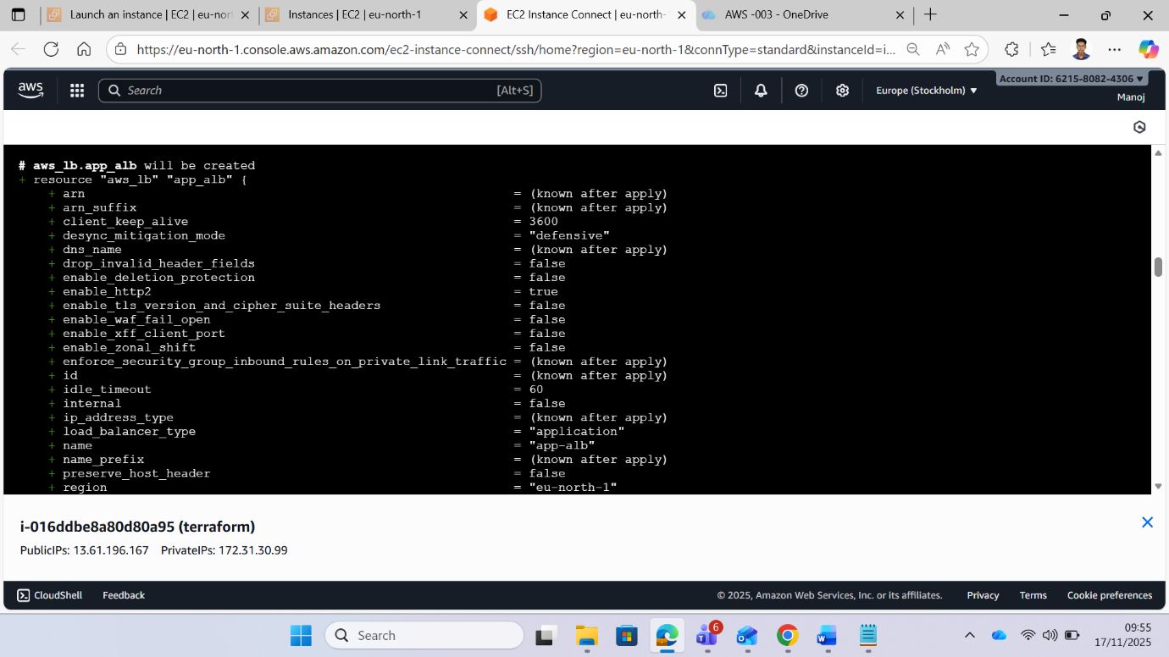

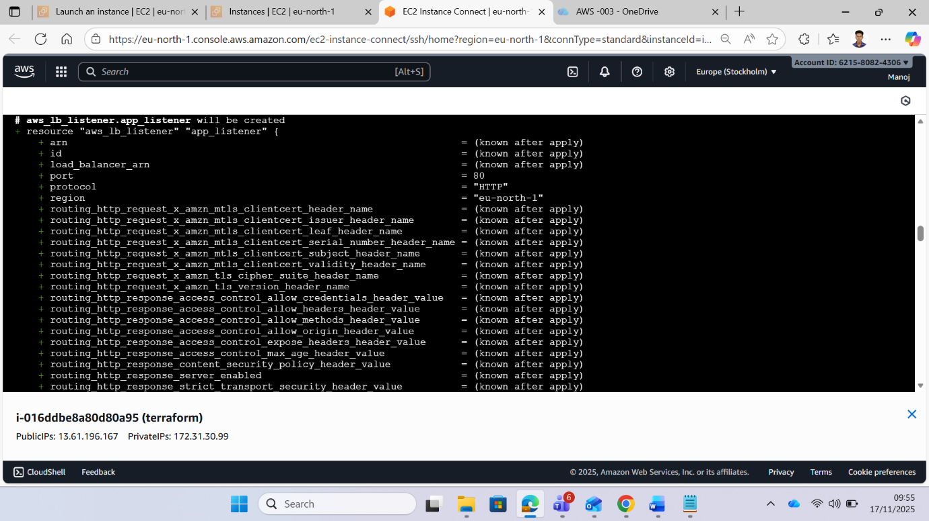

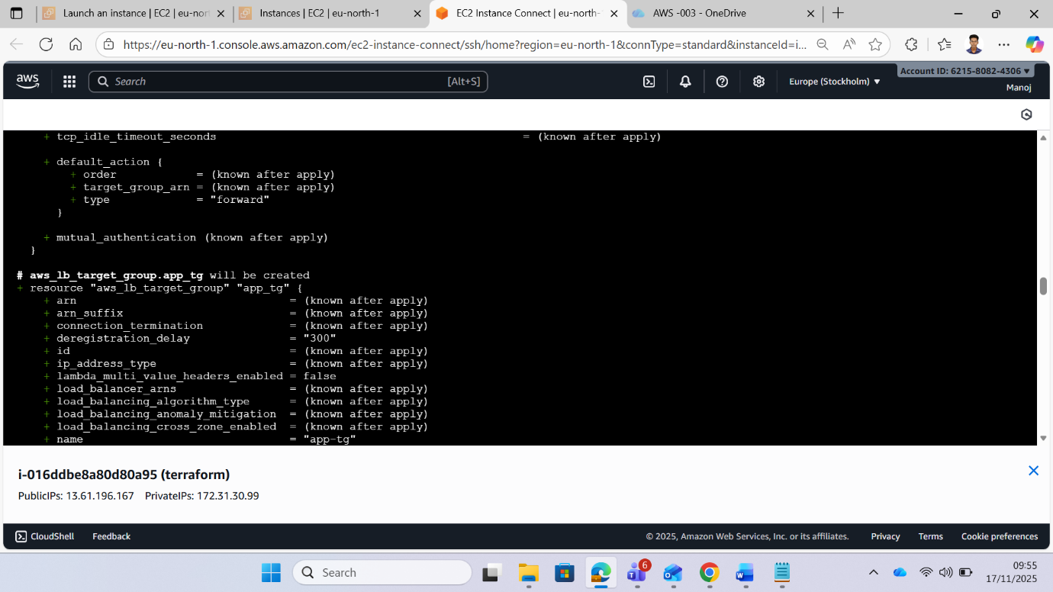

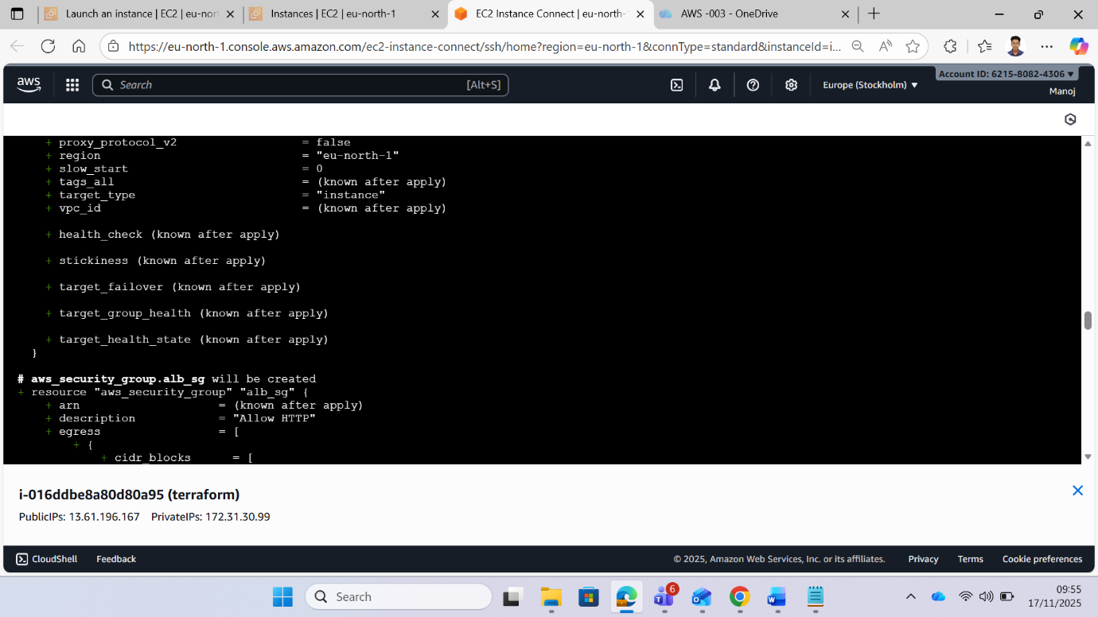

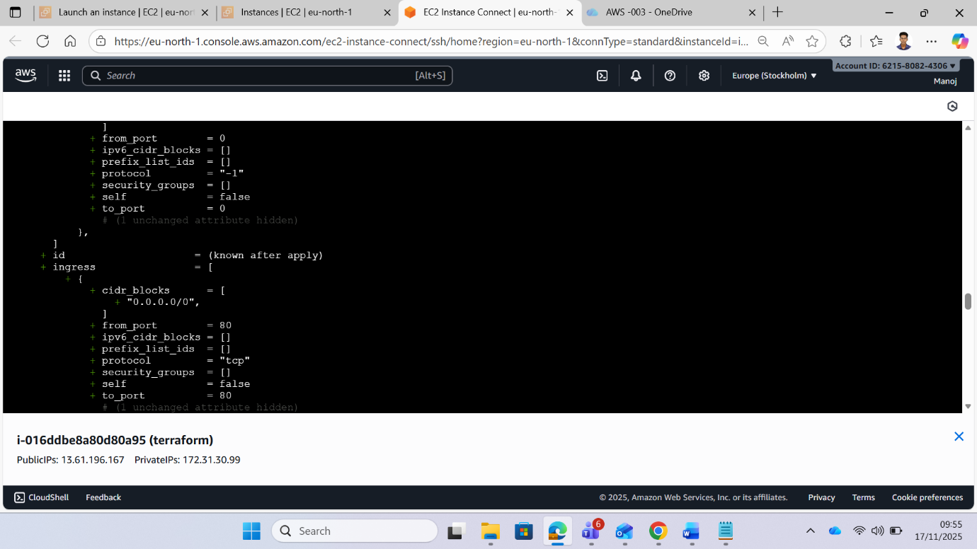

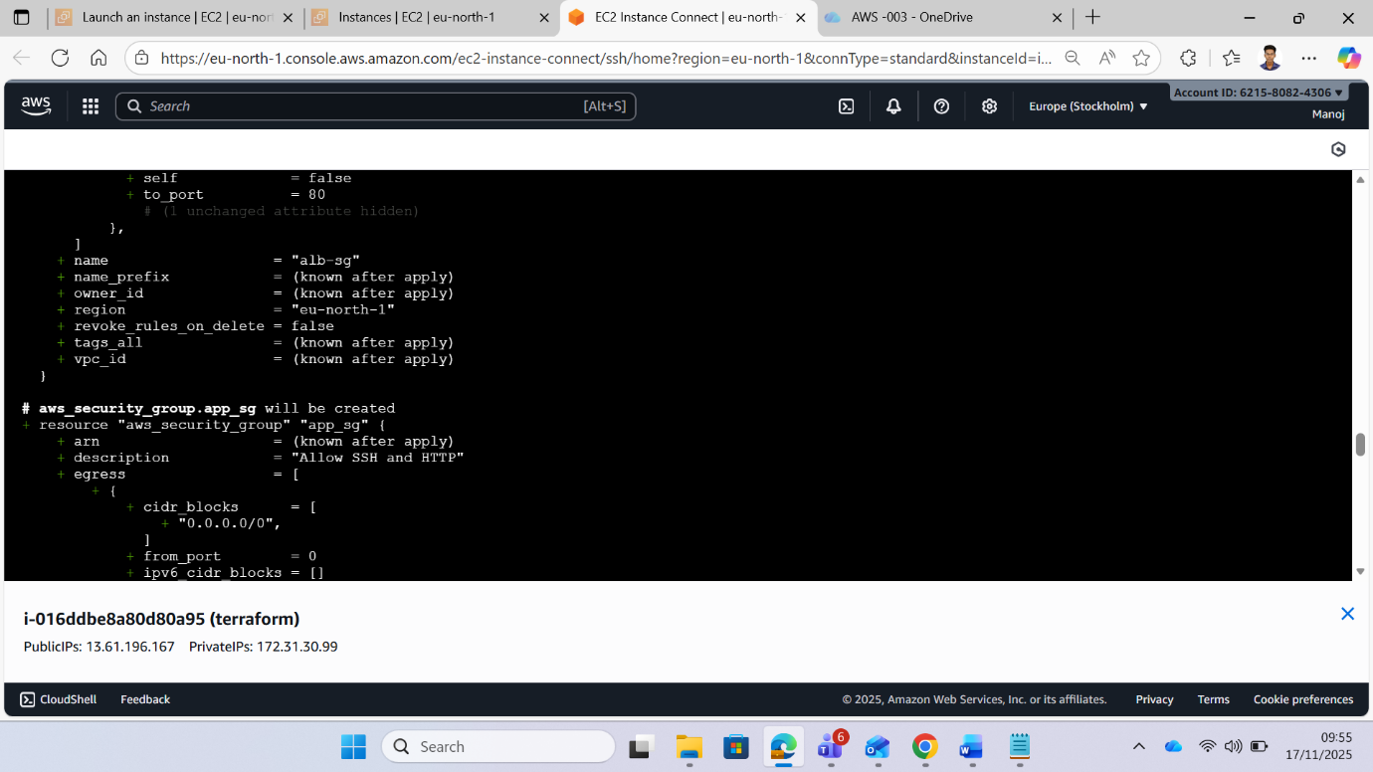

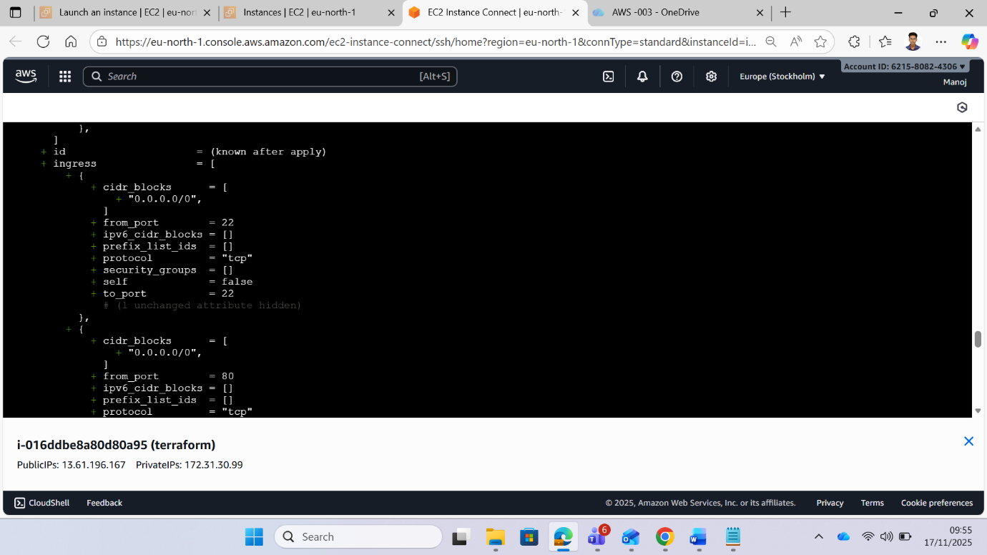

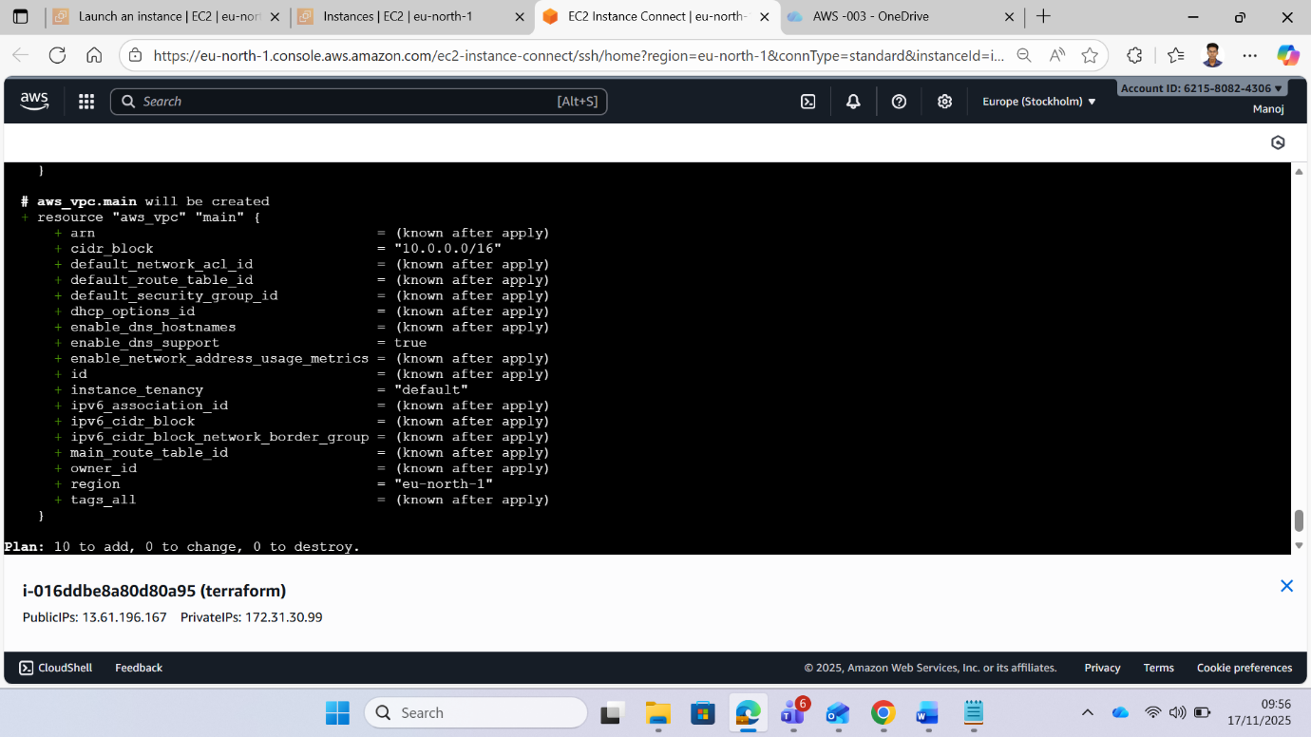

**Step 5: Run a terraform apply command**

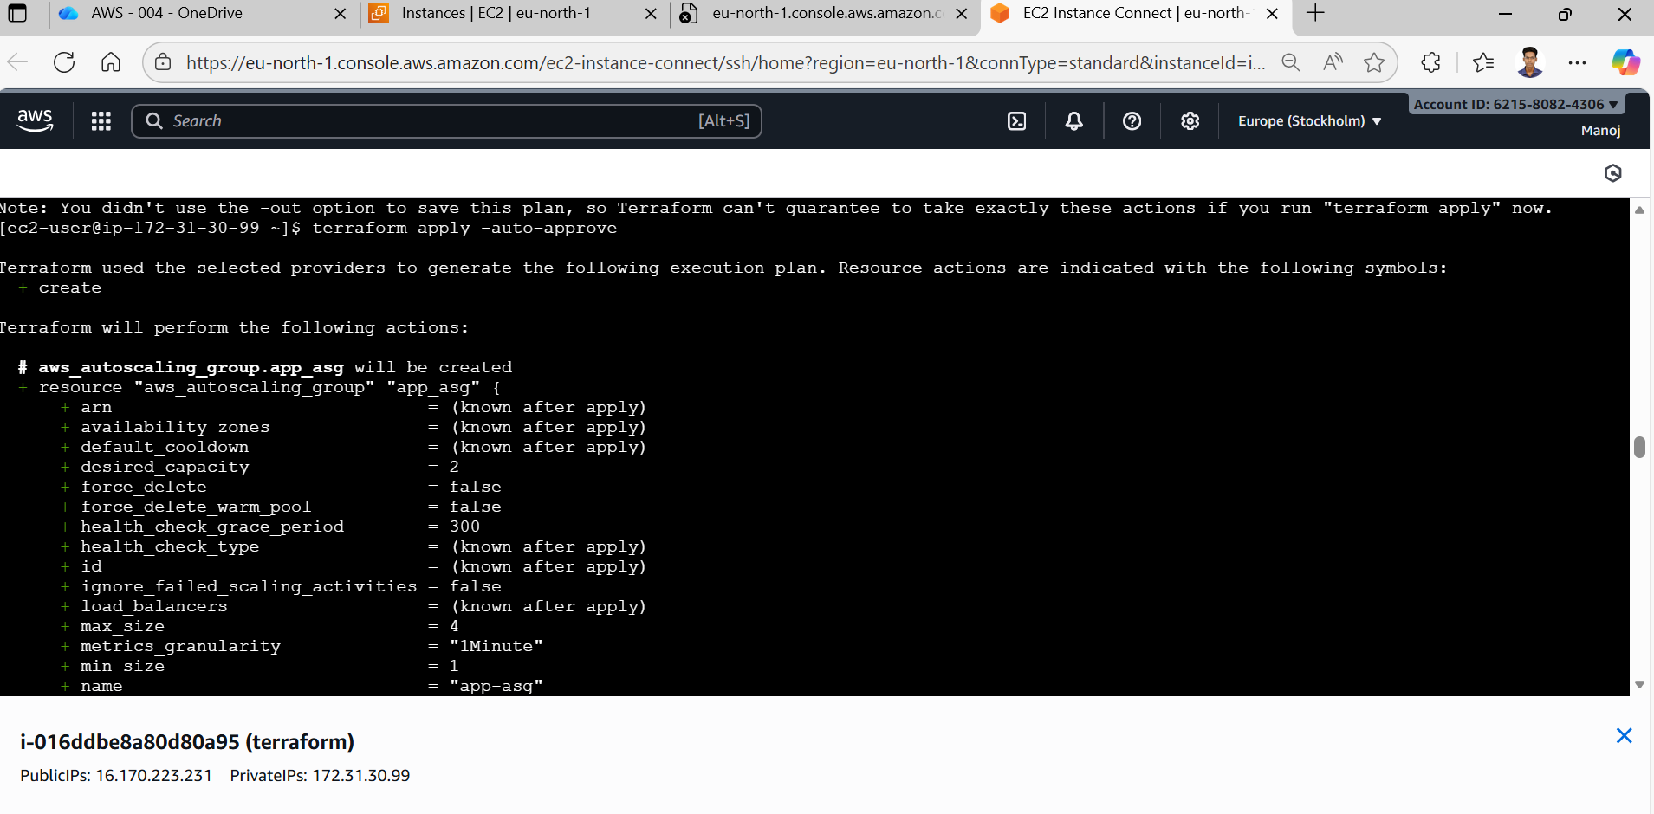

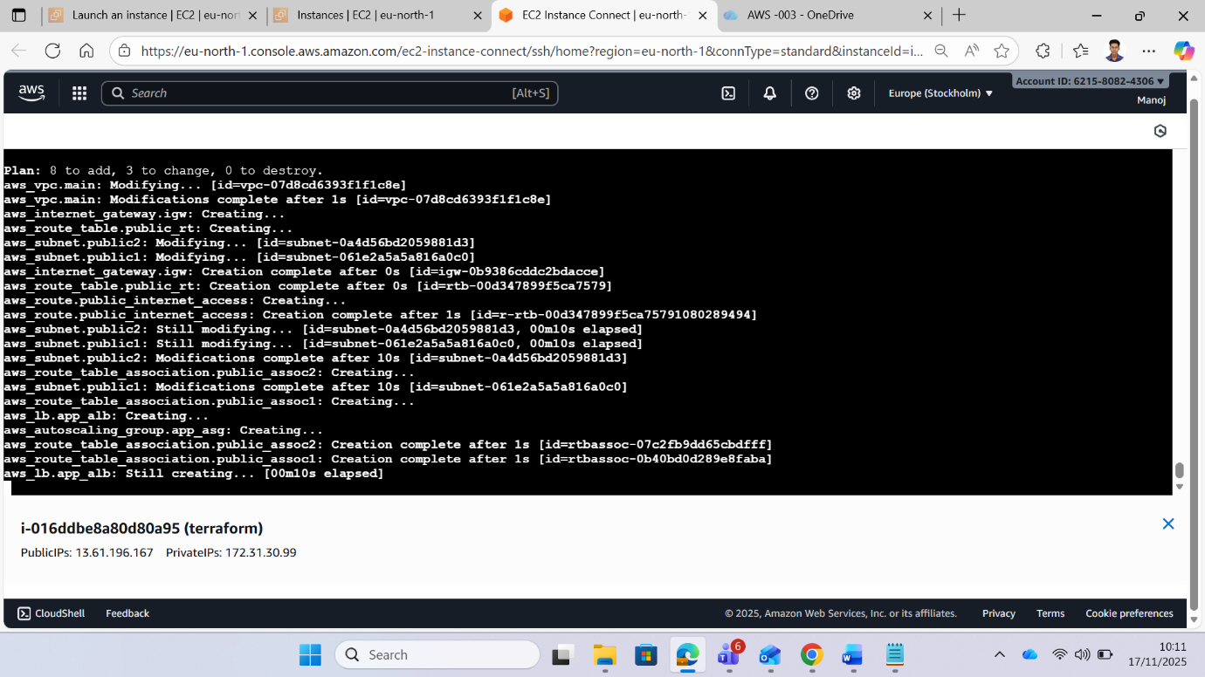

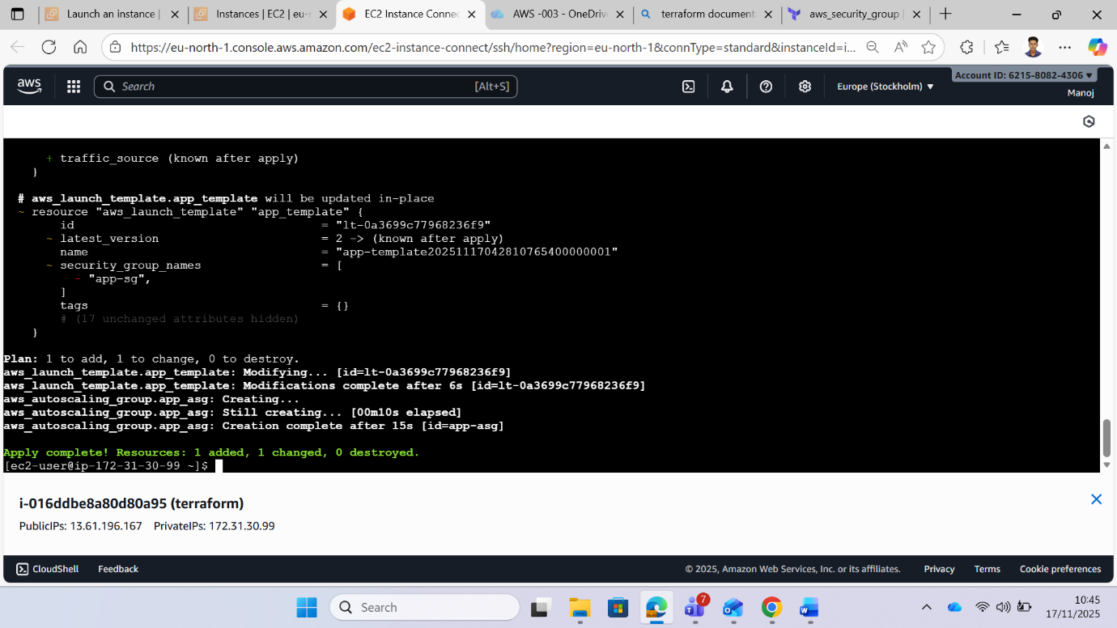

**Step 6: Check the aws console all the resource are created**

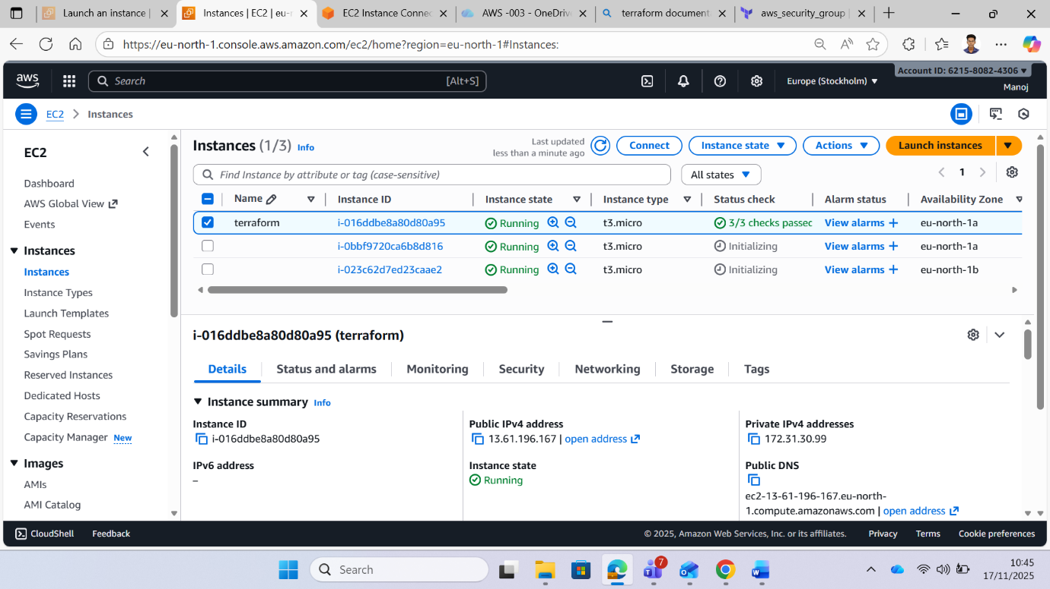

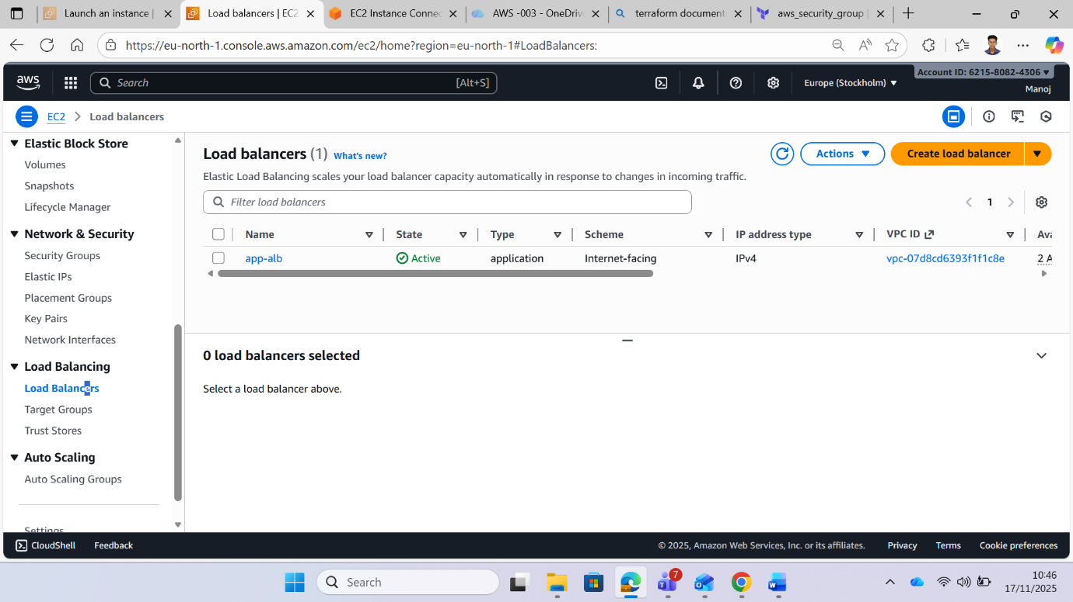

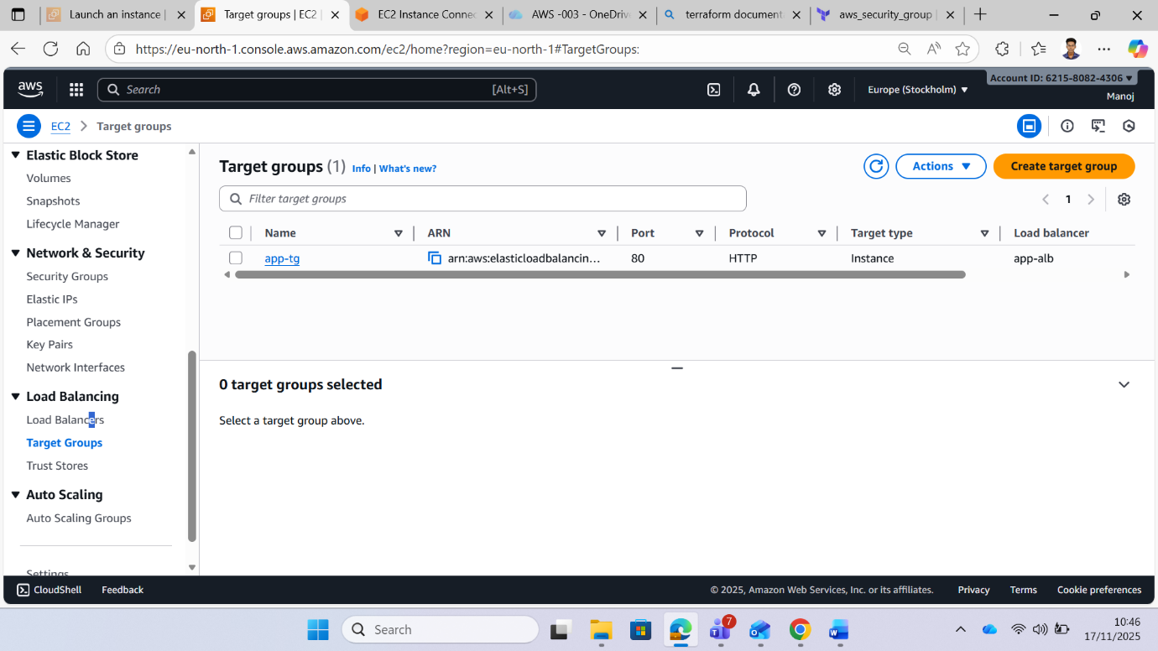

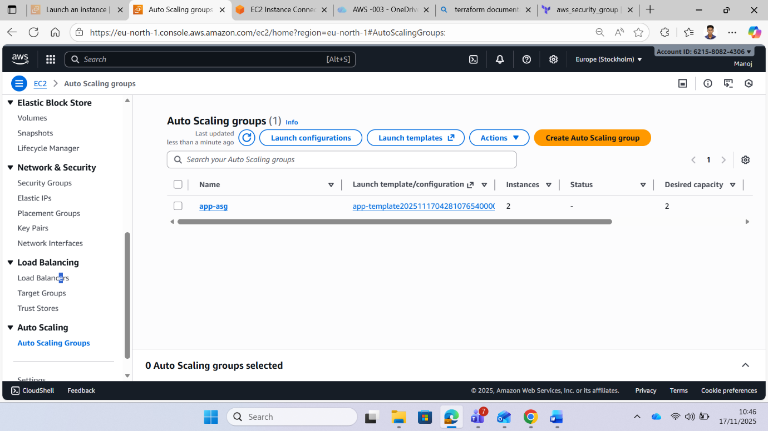

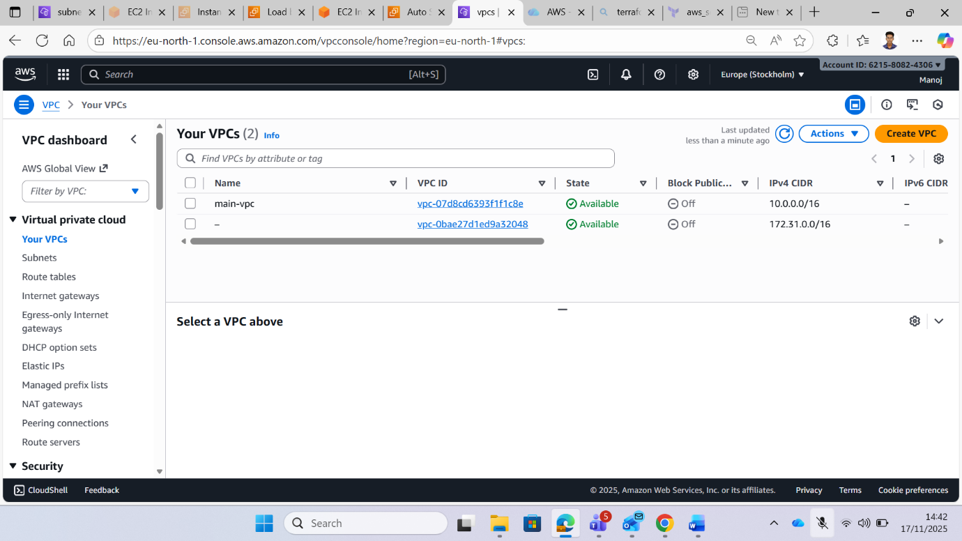

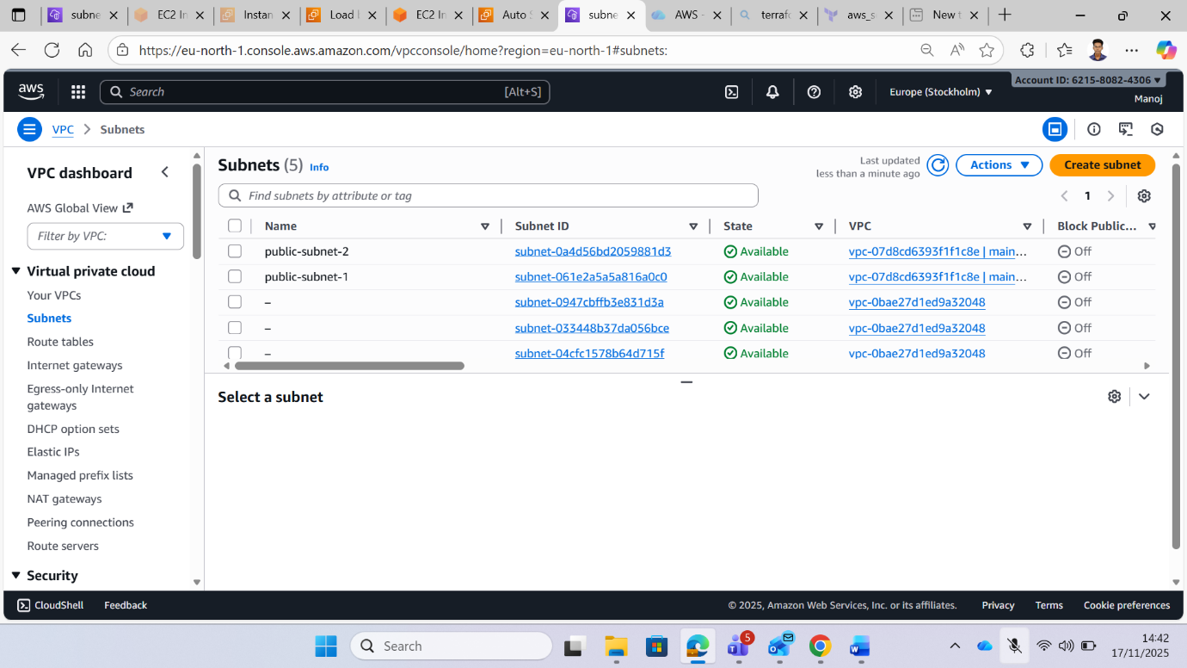

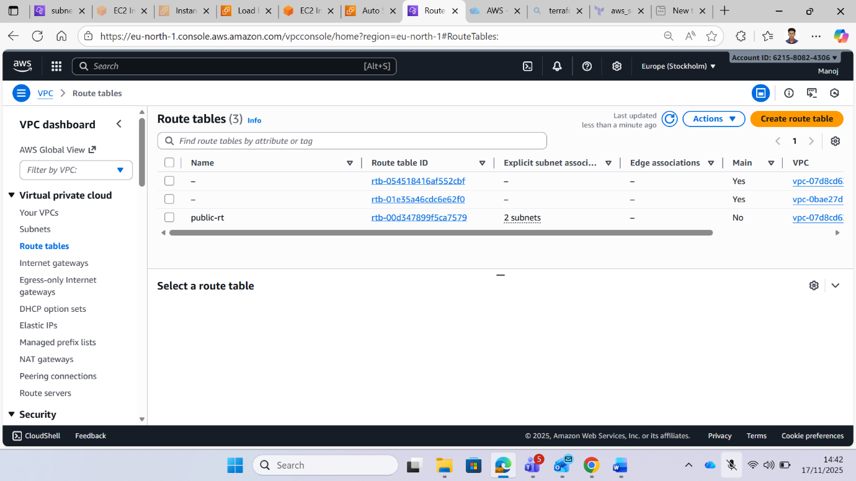

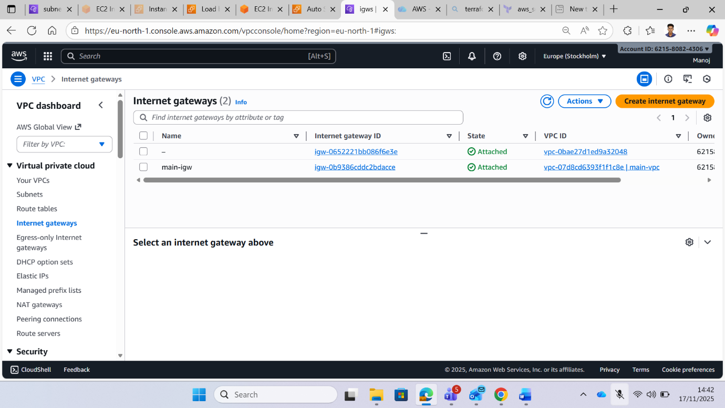

**Step 7 : Establish SSH Connection to EC2 Instance**

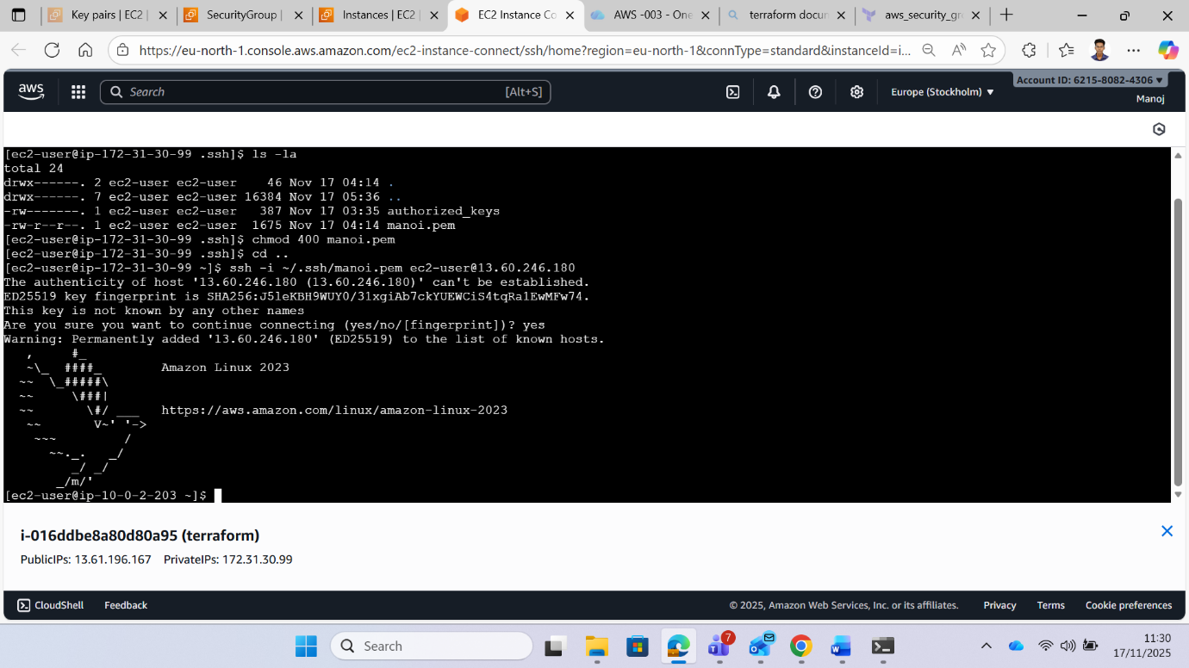

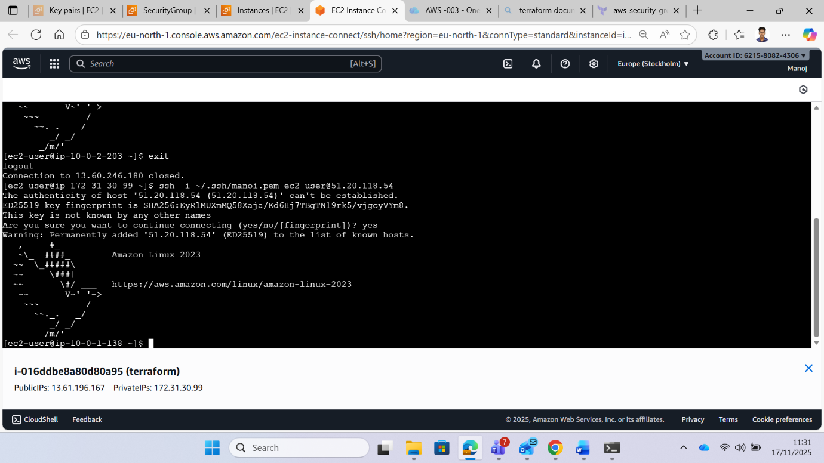

**Step 8 : Configure EC2 Instance Using Ansible**

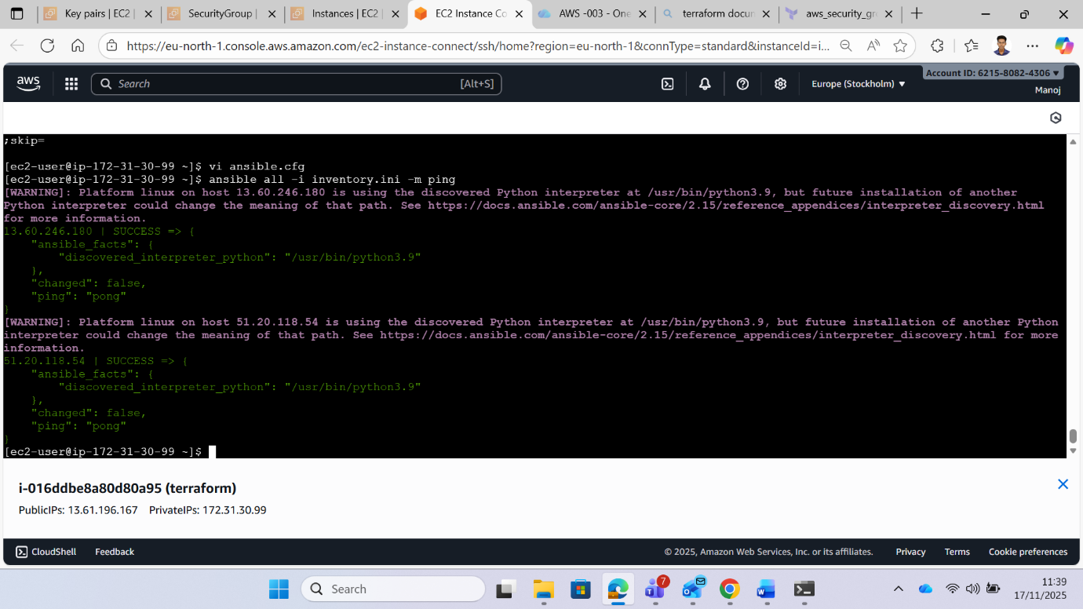

**Step 9: I Write a playbook to install and start the httpd service**

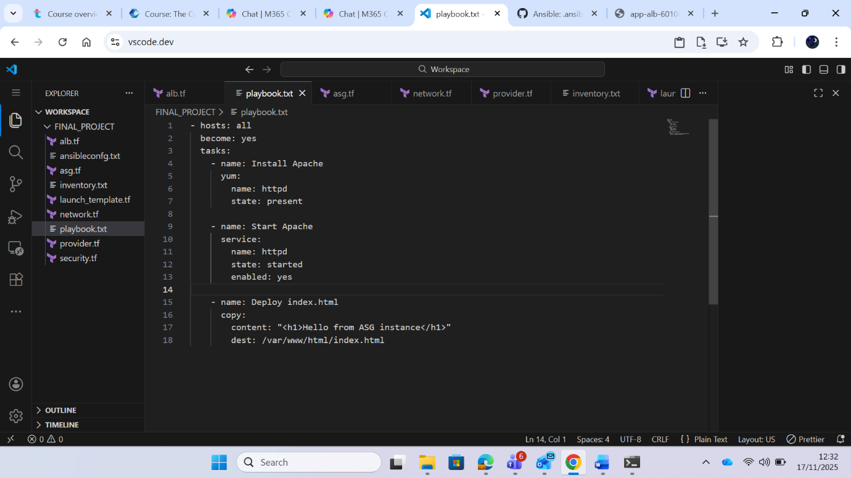

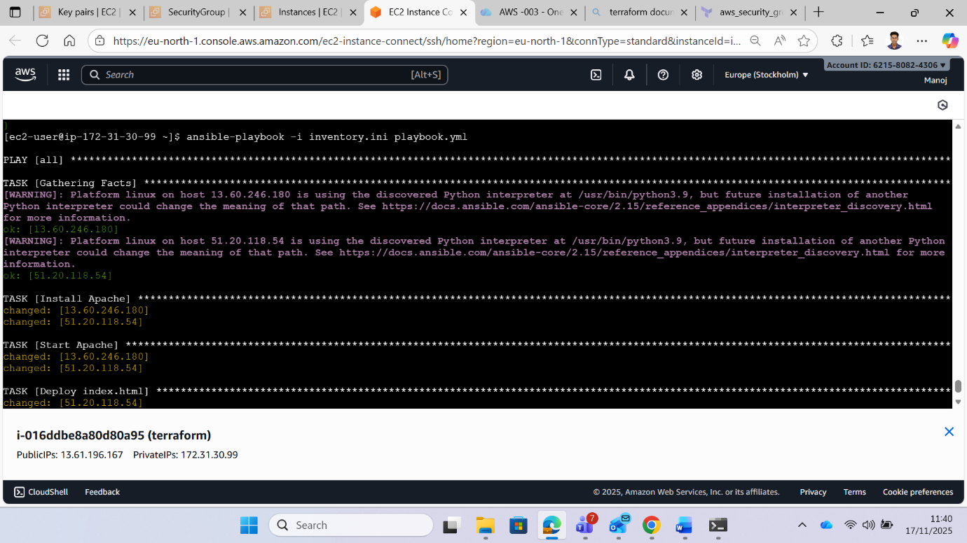

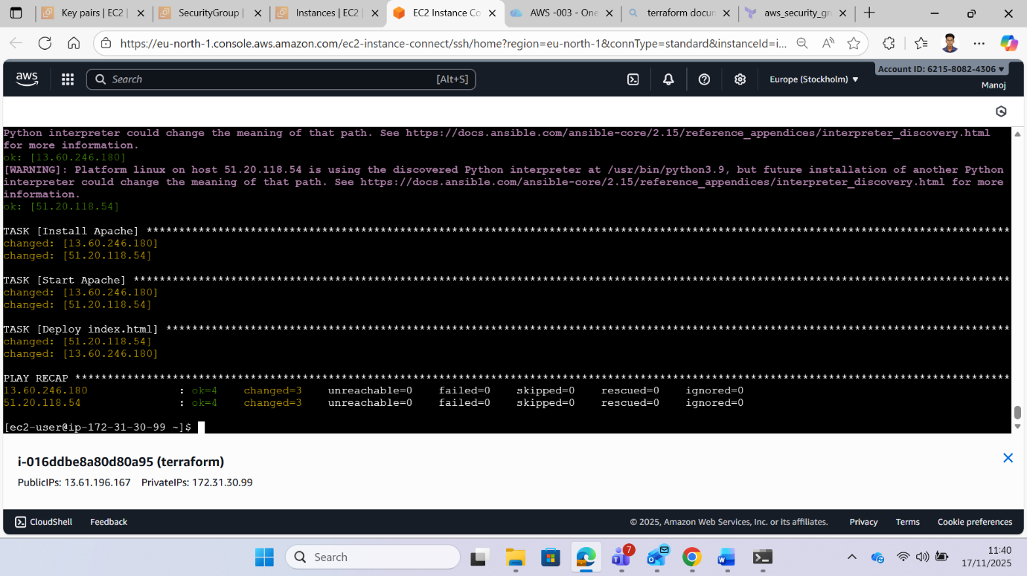

**Step 10: Verify Application Load Balancer Configuration**

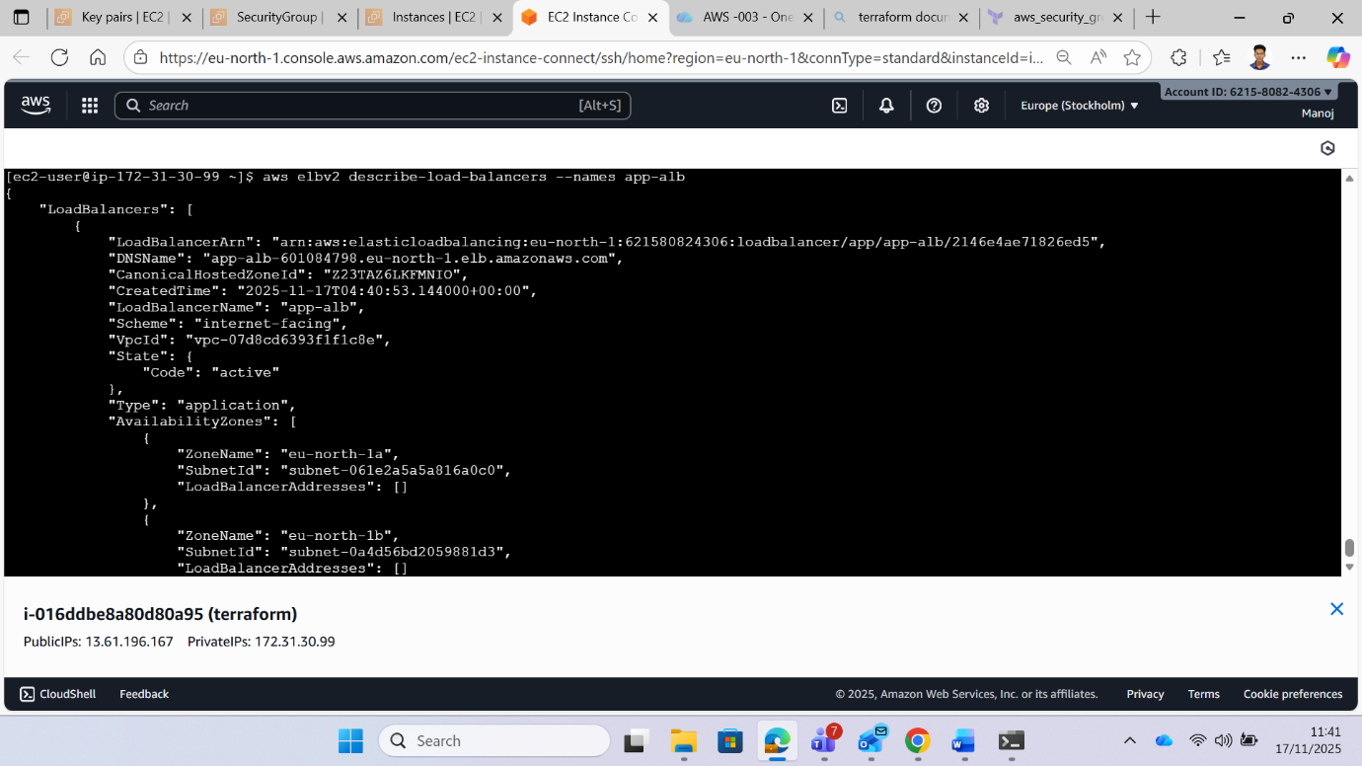

**Step 11: Copy ALB DNS in browser**

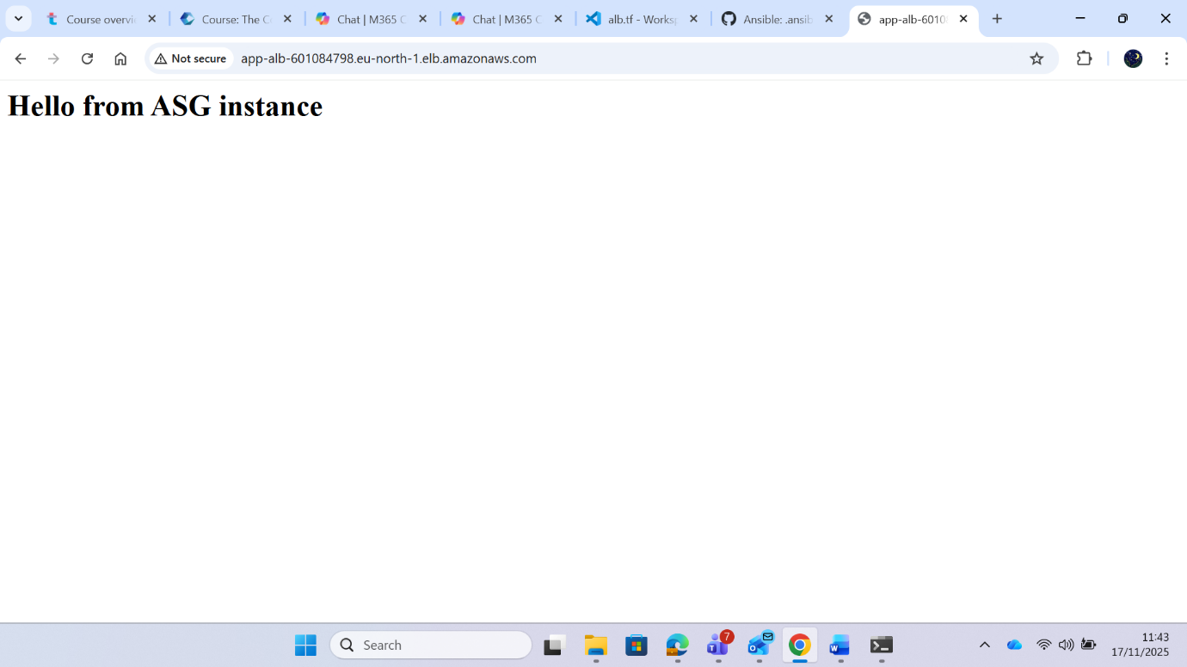

**Step 12: Test Application via Load Balancer DNS**

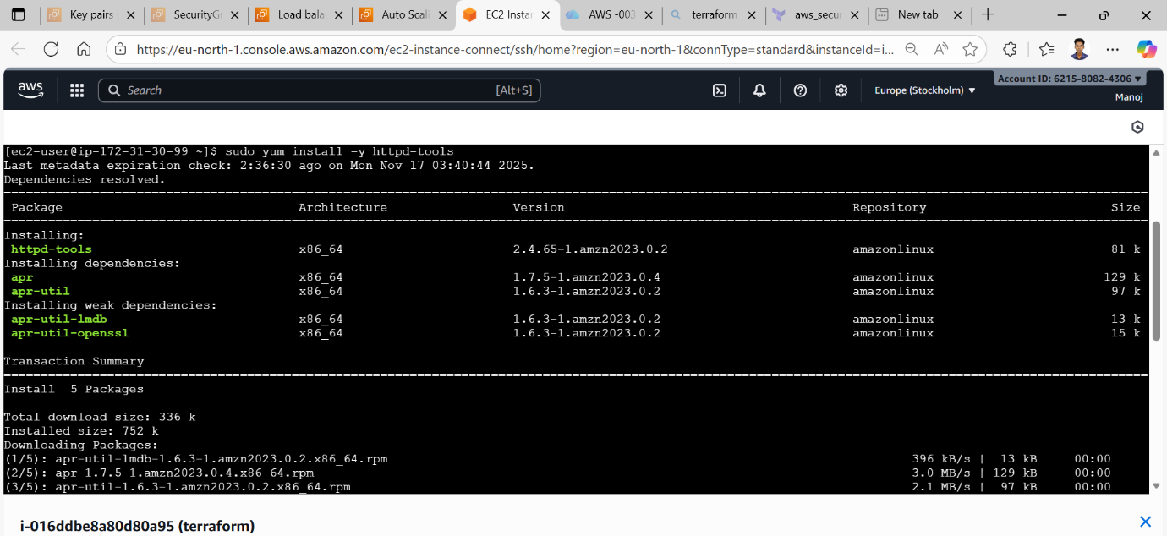



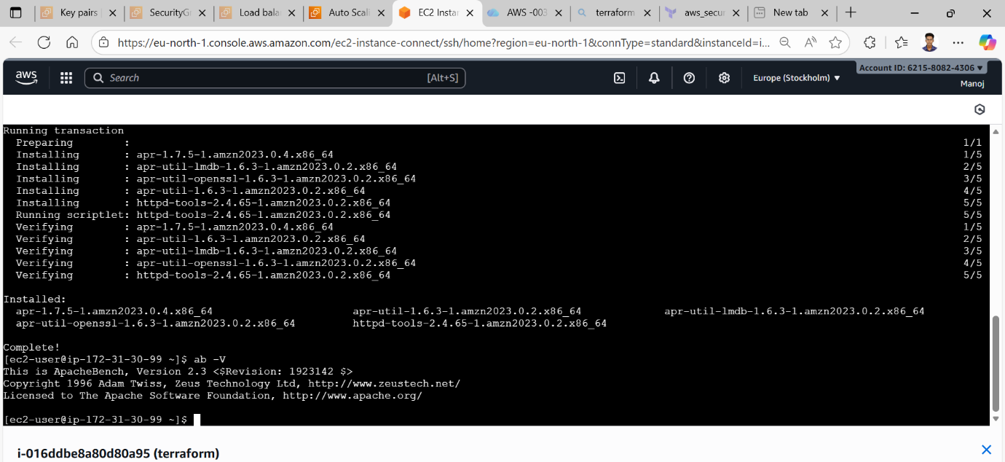

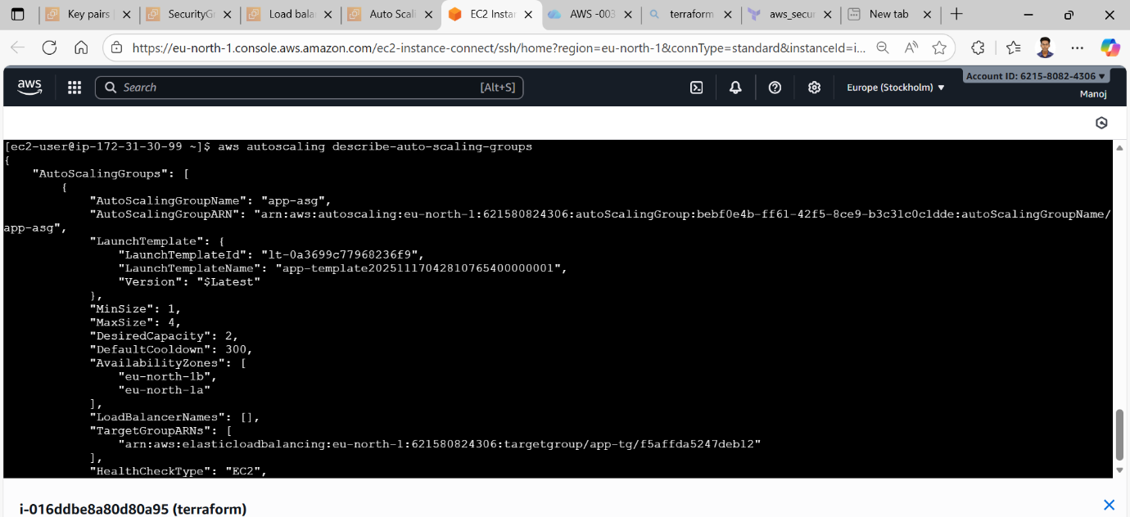

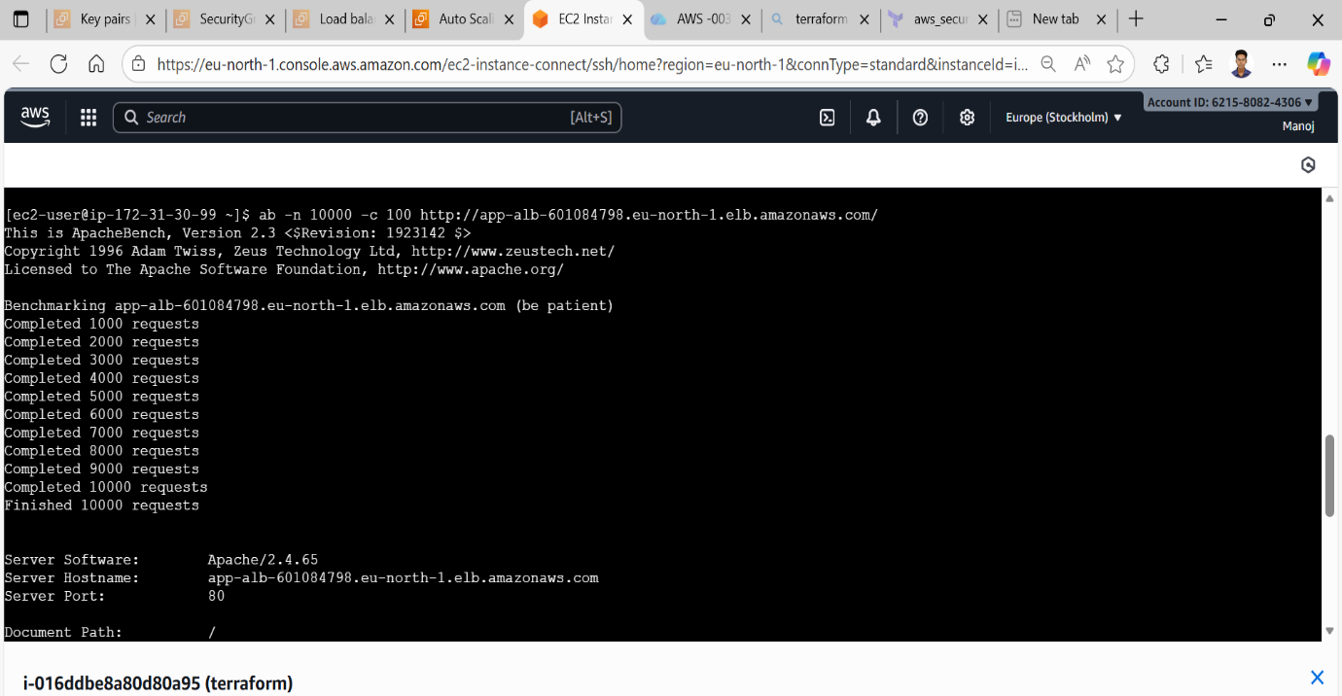

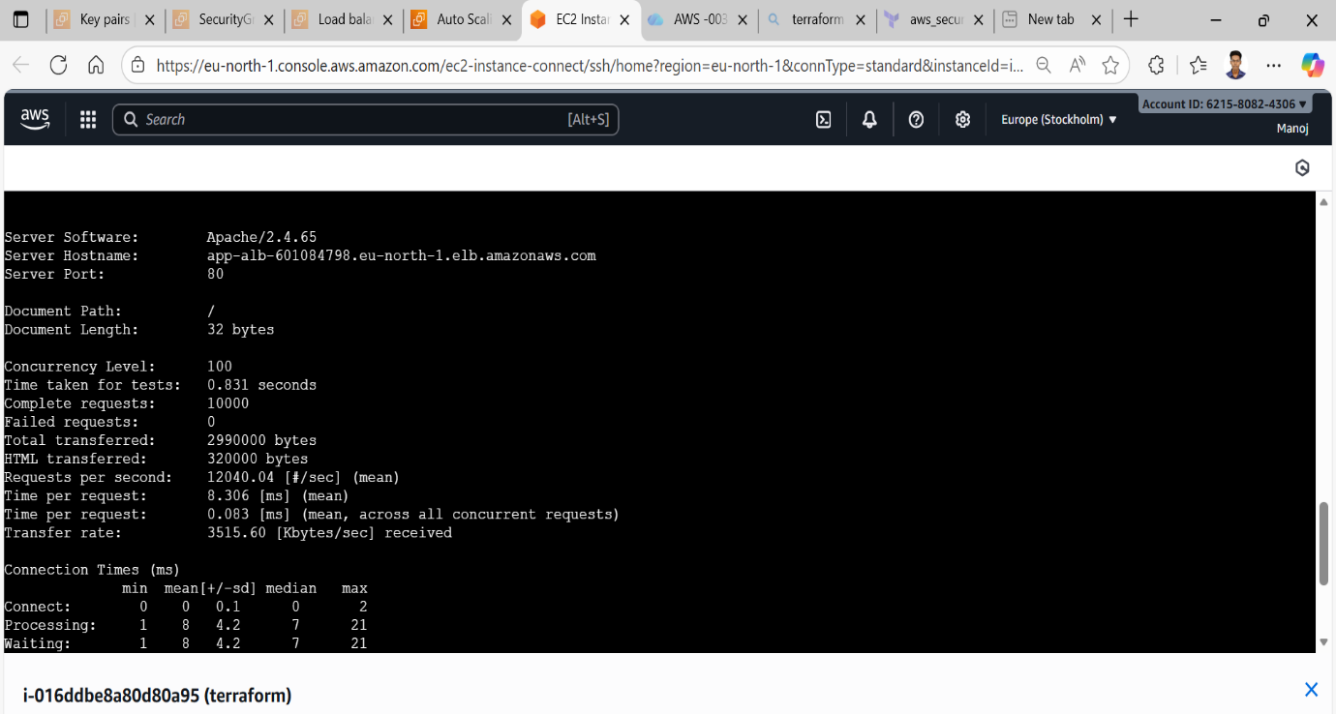

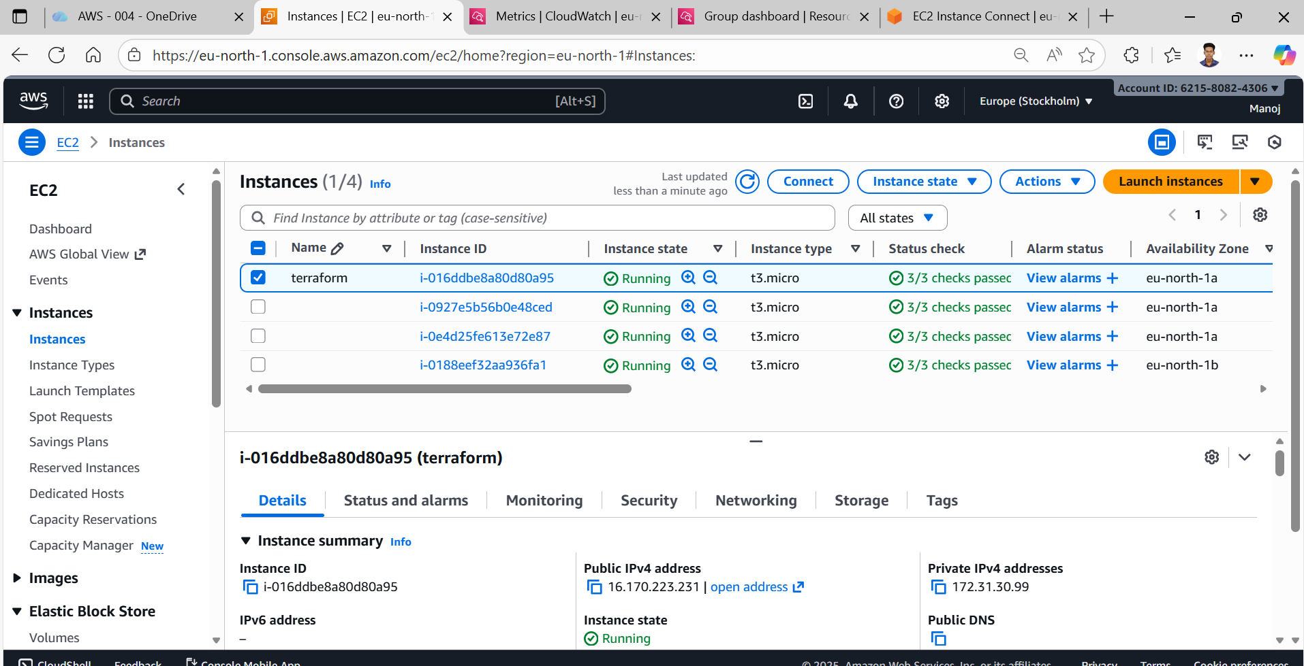

**THANK YOU**